Subject: Manufacturing Technology-I

B.Tech.(Mechanical) – 2011 Sem: IV

Assignment – I

1. | A cast iron cylinder of 50 mm outside diameter, 20 mm inside diameter and 75 mm long is to be obtained by sand casting.  (a). Design and fabricate the requisite pattern assuming that the internal hole is to be finished by machining.  (b). Design and fabricate the core, gating system elements and riser.  (c). Calculate and compare the theoretical mould cavity filling time with the experimental one. Also, calculate and compare the theoretical solidification time with the experimental one. Explain the reasons for the difference.
2. | (a). Examine the following component, which has to be obtained by sand casting and comment about the good and bad features from processing point of view.  (b). Design the pattern, core and core box by considering the various allowances and other casting requirements.  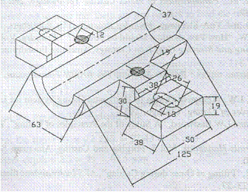  (c). Work out the details of the gating system design, explaining at each stage the choice of the parameters and values so chosen. Also, give the details of the mould with dimensions and the arrangements of the gating elements.

